**Chad country profile**

Published

8 May 2018

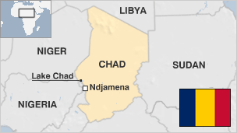

**A largely semi-desert country, Chad is rich in gold and uranium and stands to benefit from its recently-acquired status as an oil-exporting state.**

Chad's post-independence history has been marked by instability and violence, stemming mostly from tension between the mainly Arab-Muslim north and the predominantly Christian and animist south.

Chad became an oil-producing nation in 2003, with the completion of a $4bn pipeline linking its oilfields to terminals on the Atlantic coast.

However, it suffers from inadequate infrastructure, and internal conflict. Poverty is rife, and health and social conditions compare unfavourably with those elsewhere in the region.

* Read more [country profiles](http://news.bbc.co.uk/1/hi/country_profiles/) - Profiles by [BBC Monitoring](http://bbc.co.uk/monitoring)

**President: Idriss Deby**

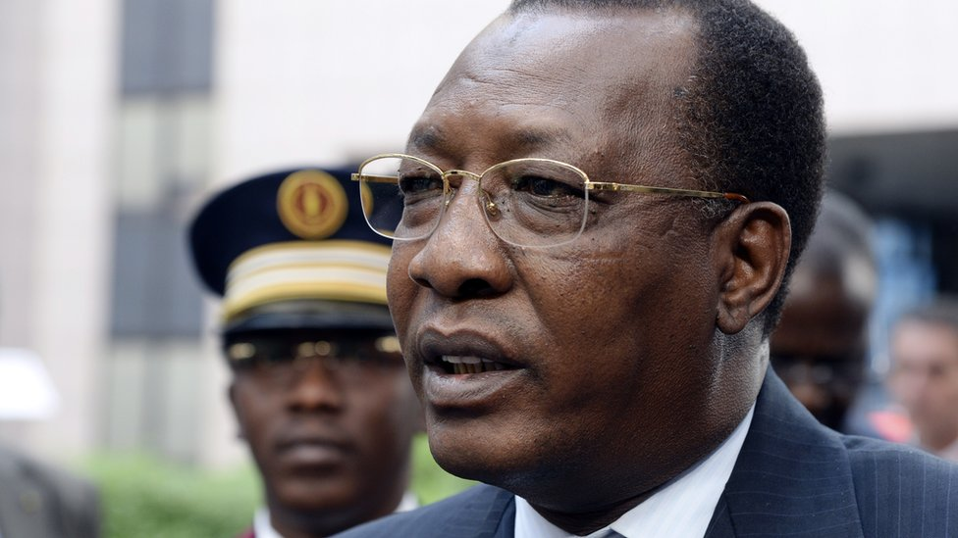image copyrightGetty Images

Idriss Deby came to power in 1990 after toppling Chadian President Hissene Habre - with the help of the French secret service.

A shrewd tactician, Mr Deby had been President Habre's chief-of-staff, leading a series of victories over rebel forces in the 1980s and earning a reputation for courage and military prowess.

After six years in office, he set up Chad's first multi-party political system and won elections that year.

But Mr Deby appeared to have little genuine domestic support. Critics say his single biggest failure was putting his clan before his country.

He is also thought to have health problems and has been known to fly to Paris for treatment to his liver.

He gained a fifth term in elections in April 2016.

In 2018, parliament passed a controversial change to the constitution that bolsters President Deby's powers despite opposition warnings that it would undermine democracy.

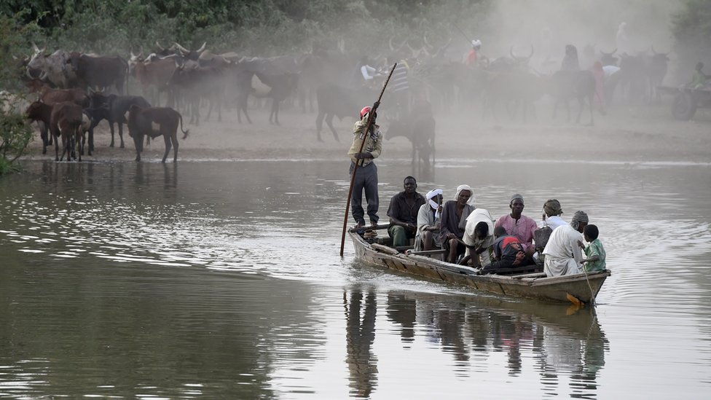image copyrightGetty Images

image captionLake Chad is an important source of water for millions of people in the four countries surrounding it

Radio is the main medium, but state control of many broadcasting outlets allows few dissenting views.

The only television station, Tele-Tchad, is state-owned and its coverage favours the government.

Reporters Without Borders has on several occasions condemned the arrest of journalists in Chad, including the publisher of an privately-owned newspaper in October 2015.

# Chad profile - Timeline

Published

8 May 2018

## A chronology of key events:

**1883-93** - Sudanese adventurer Rabih al-Zubayr conquers the kingdoms of Ouadai, Baguirmi and Kanem-Bornu, situated in what is now Chad.

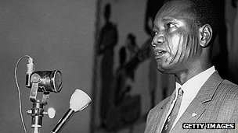image copyrightGetty Images

image captionIndependent Chad's first president, Francois Tombalbaye, was assassinated

**1900** - France defeats al-Zubayr's army.

**1913** - French conquest of Chad completed; Chad becomes a colony within French Equatorial Africa.

**1946** - Chad becomes a French overseas territory with its own territorial parliament and representation in the French National Assembly.

**1960** - Chad becomes independent with a southern Christian, Francois - later Ngarta - Tombalbaye, as president.

**1963** - The banning of political parties triggers violent opposition in the Muslim north, led by the Chadian National Liberation Front, or Frolinat.

**1966** - Northern revolt develops into a fully-fledged guerrilla war.

**1973** - French troops help put down the northern revolt, but Frolinat continues guerrilla operations throughout the 1970s and 1980s with the help of weapons supplied by Libya.

## Libyan intervention

**1975** - Tombalbaye deposed and killed in coup led by another southern Christian, Felix Malloum.

**1977** - Libya annexes the northern Chadian Aouzou strip.

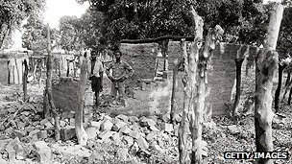image copyrightGetty Images

image captionVillagers stand among houses wrecked in a scorched-earth offensive by President Habre's troops in 1984

**1979** - Malloum forced to flee the country; a coalition government headed by a Muslim northerner, Goukouni Oueddei, assumes power.

**1980** - Libya sends in troops to support Oueddei in his fight against the Army of the North, led by a former prime minister, Hissene Habre.

**1981** - Libyan troops withdraw at Oueddei's request.

**1982** - Habre seizes power. He is later accused of mass political killings during his rule.

**1983** - The Organisation of African Unity recognises Habre's government, but Oueddei's forces continue resistance in the north with Libyan help.

**1987** - The combined troops of Frolinat and the Chadian Government, with French and US assistance, force Libya out of the entire northern region apart from the Aouzou strip and parts of Tibesti.

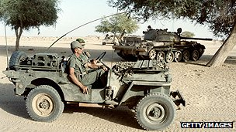image copyrightGetty Images

image captionFrench soldiers pass a Libyan tank during the Chadian-Libyan conflict in 1987

## First democratic elections

**1990** - Habre toppled by former ally, Idriss Deby.

**1993** - National democracy conference sets up a transitional government with Deby as interim president and calls for free elections within a year.

**1994** - International Court of Justice rejects Libyan claims on Aouzou and rules that Chad had sovereignty over the strip.

**1996** - Deby wins Chad's first multi-party presidential election.

**1997** - Deby's Patriotic Salvation Movement triumphs on legislative elections.

**1998** - The Movement for Democracy and Justice in Chad, led by Deby's former Defence Minister, Youssouf Togoimi, begins armed rebellion against the government.

**2001** - Senegalese court rules that upholds ruling that former Chadian President Habre should not be made to stand trial in Senegal, where he is in exile. It decided that Senegal's courts do not have the jurisdiction to try Habre on torture charges during his eight years in power in Chad.

**2001** May - Deby declared winner in controversial presidential poll.

## Peace deals

**2002** January - Government and Movement for Democracy and Justice in Chad (MDJT) rebels sign Libyan-brokered peace deal intended to end three-year civil war.

**2002** May - MDJT rebels and government forces clash in the far north; 64 are killed in the first outbreak of fighting since January's peace accord.

**2003** January - Government signs peace deal with National Resistance Army (ANR) rebels, active in the east.

**2003** October - Chad becomes an oil exporter with the opening of a pipeline connecting its oil fields with Cameroon.

**2003** December - MDJT, government sign another peace accord. MDJT hardliners reject deal.

## Darfur impact

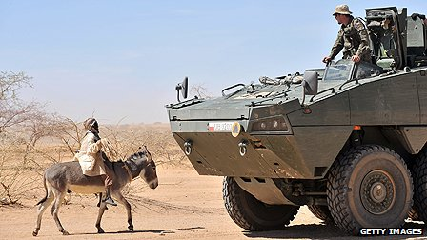image copyrightGetty Images

image captionEuropean peacekeepers deployed along the eastern border to protect refugees fleeing from the conflict in Darfur, Sudan

**2004** January-February - Thousands of Sudanese refugees arrive in Chad to escape fighting in Darfur region of western Sudan.

**2004** April-May - Chadian troops clash with pro-Sudanese government militias as fighting in Sudan's Darfur region spills over the border.

**2005** June - Voters back constitutional changes which allow the president to stand for a third term in 2006.

**2005** November - Former president, Hissene Habre, is arrested in Senegal over allegations of crimes against humanity.

**2005** December - Rebels attack the town of Adre, near the Sudanese border. Chad accuses Sudan of being behind the incident.

**2006** January - President Deby backs a law to reduce the amount of oil money spent on development. The move angers the World Bank, which suspends loans and orders the account used to collect oil revenues to be frozen.

**2006** March - Government says an attempted military coup has been thwarted.

## Rebel battle

**2006** April - Rebels seeking to oust President Deby battle government forces on the outskirts of the capital. Hundreds of people are killed. Chad cuts diplomatic ties with Sudan, accusing it of backing the rebels.

**2006** May - President Deby is declared the winner of presidential elections. The main opposition parties boycott the poll.

**2006** January-June - Thousands of refugees flee eastern areas as marauding Arab Janjaweed militia from Sudan's Darfur region penetrate deeper into Chad.

**2006** July - Parliament approves the establishment of Chad's first state oil company, the Societe des Hydrocarbures du Tchad (SHT), which is expected to give Chad greater control over its energy assets.

**2006** August - President Deby threatens to expel US energy giant Chevron and Malaysia's Petronas for failing to honour tax obligations, but relents after coming to an agreement with the companies.

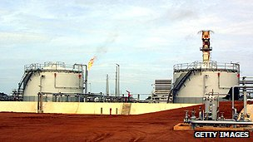image copyrightGetty Images

image captionChad started producing oil in 2003

**2006** November - State of emergency imposed in eastern areas bordering Sudan's Darfur region after a spate of ethnic violence.

**2006** December - Private newspapers stop publishing and several radio stations alter their programming to protest against state censorship under the state of emergency.

**2007** February - UN refugee agency warns that violence against civilians in Chad could turn into a genocide.

**2007** May - Chad and Sudan agree to stop conflict spilling across their borders but critics fear the agreement is unlikely to reduce the violence.

**2007** August - Government, opposition agree to delay parliamentary elections by two years to 2009.

**2007** September - UN Security Council authorises a UN-European Union peacekeeping force to protect civilians from violence spilling over from Darfur in neighbouring Sudan.

## Emergency

**2007** October - Emergency declared along eastern border and in the desert north.

Scandal as French charity tries to airlift a group of 100 ''orphans'' to Europe in what Chad describes as a smuggling operation.

**2007** December - Six French aid workers are convicted of child-trafficking and sentenced to eight years' hard labour, but are then repatriated to serve their sentences at home.

**2008** January - European Union approves a peacekeeping force for Chad to protect refugees from violence in Darfur.

**2008** February - Rebel offensive reaches the streets of N'Djamena, coming close to the presidential palace; France sends extra troops.

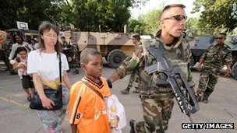image copyrightGetty Images

image captionFrench forces helped defend the capital against a rebel attack in 2008, and to evacuate foreigners

Rebels are repulsed in fighting that leaves more than 100 dead.

**2008** March - The presidents of Chad and Sudan sign an accord in Senegal aimed at halting five years of hostilities between the two countries.

**2008** May - Violence between Chadian and Sudanese militias flares up, leading to Sudan cutting diplomatic relations and Chad responding by closing its border and cutting economic ties.

**2008** July - Security forces say they killed more than 70 followers of Muslim spiritual leader Ahmat Israel Bichara, who had threatened to launch a holy war, in fighting in southeast Chad.

**2009** January - Eight rebel groups unite to form new rebel alliance, the Union of Resistance Forces (UFR), with Rally of Democratic Forces leader Timan Erdimi as its leader.

**2009** March - European Union peacekeepers in eastern Chad hand over to a new, larger UN force known as Minurcat.

**2009** May - UN Security Council condemns a major anti-government rebel offensive in the east.

**2009** November - UN accuses Sudan of supporting URF rebels in Chad with arms and ammunition.

Six international aid groups, including the International Red Cross, suspend work in eastern Chad, citing risk of their staff being abducted or killed.

## Rapprochement

**2010** February - President Deby and his Sudanese counterpart, Omar al-Bashir, hold talks in Sudanese capital Khartoum, in their first meeting for six years; President al-Bashir says his country is ready for full normalisation of ties.

Chad and Sudan agree to deploy joint force to monitor situation along their shared border.

**2010** March - Chad agrees to let UN peacekeeping force (Minurcat) to stay on for two months beyond the end of its mandate in mid-March, despite repeated criticism of its performance.

**2010** April - Chad-Sudan border reopens seven years after Darfur conflict forced its closure.

**2010** June - Voter registration closes ahead of parliamentary polls in November and presidential elections in April 2011.

**2010** May - UN Security Council votes to withdraw Minurcat peacekeeping force from Chad and Central African Republic, deployed to protect displaced Chadians and refugees from Sudan's Darfur.

**2010** July - Sudanese president Omar al-Bashir travels to Chad to attend a meeting of regional leaders - defying two warrants for his arrest issued by the International Criminal Court.

**2010** October - Main political parties agree new timetable for postponed presidential and parliamentary polls.

Experts meet to discuss how to protect Lake Chad, which has shrunk dramatically over past 50 years.

## 50 years of independence

**2011** January - Chad marks 50 years of independence from France.

**2011** February - Parliamentary elections.

**2011** April - Presidential election, boycotted by opposition. President Idriss Deby is declared winner.

**2011** July **-** Following a UN appeal, Senegal suspends the planned repatriation of former President Hissene Habre to his homeland, where he has been sentenced to death for crimes against humanity while president from 1982-1990.

**2012** April - President Deby calls on countries neighbouring northern Nigeria to set up a joint military force to tackle Boko Haram militants. He warns the Islamists could destabilise the whole Lake Chad basin area.

**2012** August - Senegal, African Union agree to set up special tribunal to try Chad's former leader Hissene Habre.

**2012** September - Leader of rebel group FPR, Abdel Kader Baba Ladde, surrenders.

**2013** Jan-March - Chadian troops help France drive al-Qaeda allies out of northern Mali.

**2013** April - Chad agrees to send more troops to the Central African Republic to help stabilise it after a recent coup. Chadian forces have been present in the east of the country for months.

**2013** May - Several people including an opposition MP and army officers are arrested in an alleged coup plot.

## Habre arrested

**2013** July - Former leader Hissene Habre is arrested in Senegal. Investigators seek to put him on trial for crimes against humanity. Mr Habre went to Senegal after being ousted in 1990. Rights groups say 40,000 people were killed under his rule.

**2013** October - London-based rights group Amnesty International accuses President Deby's government of killing and illegally detaining critics.

**2014** February - Chad denies claims that its troops have violated their peacekeeping role in the Central African Republic by colluding with rebels.

At a meeting in London, Chad is one of four African countries which pledge to honour a ten-year moratorium on sales of ivory, as part of efforts to curb the illegal trade.

**2014** March - Chad says it will withdraw its troops from the Central African Republic, in protest at allegations that they'd supported Muslim rebels.

**2014** May - Chad announces it is closing its border with the strife-torn Central African Republic until further notice.

**2014** July - France says it is to set up a new military operation in the Sahel region in an effort to stop the emergence of jihadist groups. The operation based in the Chadian capital N'Djamena will involve around 3,000 French troops, along with troops from Mali, Mauritania, Burkina Faso and Chad.

## Habre trial

**2015** February - Boko Haram attacks the Chadian shore of Lake Chad one month after the country pledges military support for Cameroon against the Islamist armed group.

Extraordinary African Chamber court orders Hissene Habre to stand trail on charges of war crimes and crimes against humanity. He is in custody in Senegal, where the court will sit in the first use of universal jurisdiction in Africa.

**2015** March - Seven former security officers jailed for life, five in absentia, and another three to 20 years hard labour for torturing prisoners during the rule of Hissene Habre.

**2015** July - Trial of Hissene Habre begins in Senegal.

**2016** February - President Deby announces he will run for fifth term of office in April presidential election.

**2016** May - Ex-leader Hissene Habre is found guilty of crimes against humanity and sentenced to life in prison by an African Union-backed court in Senegal.

**2017** February - President Deby announces that parliamentary elections due this year have been postponed, as the country is too short of money to hold them.

**2017** May - Nine soldiers are killed in an attack by Boko Haram militants on a military post near the border with Nigeria.

**2017** September - The rights group Amnesty International accuses the government of a brutal and growing crackdown on its critics.

**2018** March - Public sector workers end a six-week strike started after the government slashed their salaries as part of an austerity drive.

**2018** April - Parliament approves a new constitution expanding the president's powers.